Triangle Park Event Planning Guide

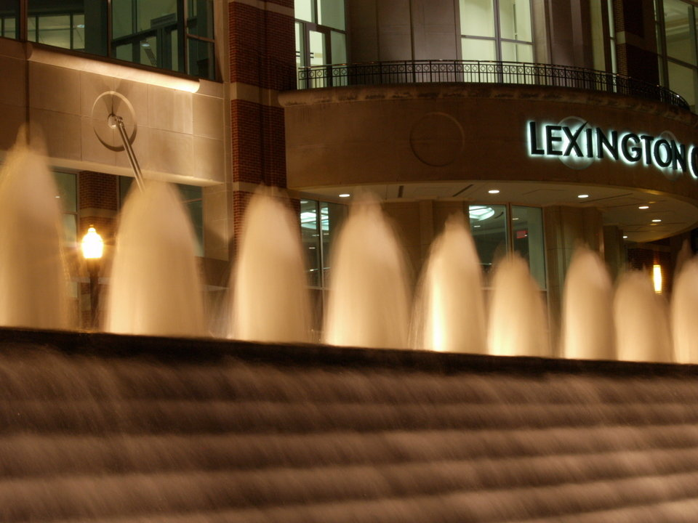

Contents Page

Overview 2

Event Locations 3 - 5

Site Map 6

Fee Information 7

Supplemental Cost and Permits 8 - 9

Additional Guidelines 9 - 11

Proposal Outline 12 - 13

Overview

About the Park
Triangle Park is a city park developed in 1980 with private funding provided by the Triangle Foundation. The park went through extensive physical renovations in 2011. Triangle Park was designed by internationally acclaimed landscape architect Robert Zion. Mr. Zion, a pioneer in modernism in landscape architecture developed many of the world’s finest parks, most notably Paley Plaza in NYC ranked 20th in the world, a vest pocket park, which caused municipalities to rethink how they utilize small public spaces. Mr. Zion designed the grounds surrounding the Statue of Liberty. The park’s 360-foot stair step cascading fountain is an iconic feature in downtown Lexington.

The park is a social place where friends meet, eat lunch, talk, listen to music and work on line with the parks free wireless network or just simple relax. Located in the heart of downtown Lexington behind the Lexington Convention Center and Rupp Arena, the park features movable chairs and café tables, large sun shielding umbrellas, an outdoor café, beautiful ivy gardens and planters that change throughout the year. This urban oasis is used year round by visitors and is available for cultural, promotional, commercial activities, weddings, corporate events and film and photo shoots.

General Information

- 1.25 acres: Includes ½ acre lawn and 32,670 square
feet of brick paved pedestrian area.
- 360 foot stair stepped water fountain.
- Approximately 300,000 users per year.
- 60,000 people walk or drive by Triangle Park each weekday.
- 300 pieces of movable furniture: 200 Parc chairs, 54 Parc café tables. 20 café umbrellas.
- Significant number of free public events, performances, and activities occur each year.
- 74 Imperial Honey Locust trees and over 8000 Daffodil bulbs planted in the ivy beds.

Event Proposal
In order to determine whether your proposed event is appropriate for Triangle Park and to determine an appropriate fee, we ask that you submit a proposal, following the outline noted within this guide. Please provide as much information as possible and answer all questions to the best of your ability. Elaborate whenever possible to provide a full and clear description of your proposed event.

For large-scale events, it is recommended that you submit your proposal as far in advance as possible, generally three to six months prior to your preferred event date(s). Proposal for other events may be considered with lead time of at least one to two months. You may submit your proposal via fax, mail, or email.

Fax
Send your completed proposal and supplemental materials to 859.253.2802, Attn. Jana Hatton.

Mail
Jana Hatton
Triangle Park Events
Lexington Center Corporation
430 W. Vine Street
Lexington, KY 40507

Email
Submit your proposal in email attachment appropriate to PC download (Microsoft Word, Excel, or PDF files) to: jhatton@lexingtoncenter.com

Response Time
Fully completed proposals are usually reviewed within one to two weeks after submission. We cannot provide an estimated fee for your event without a complete proposal. Additionally, an on-site walkthrough with the (Lexington Center Corporation) may only be scheduled once all materials are submitted and questions are answered. The original proposal may require minor revisions due to time and space restrictions, park rules, or logistical complications.

Event Locations
Please review the following event spaces and determine which space is most conducive for your event. Please keep in mind that no event can completely close the park to the public.

Upper Fountain Terrace
Located at the corner of Main Street and Broadway, this terrace area acts as the entry point to the park. The fountain can be turned off in order to allow for a platform structure which can be used to host bands and other music entities. There is access to 3 phase 60 amp service in the fountain infrastructure.
Upper Tree Terrace
The upper terrace is canopied by the grouping of imperial honey locust which provides filtered shade. This area is ideal for smaller events and functions. Users have access to the central lawn for additional room for your event. No structure is allowed on the Lawn. 3 phase 100 amp service is available.

The Lawn
The parks central lawn is a lush green oasis used by thousands of visitors. The lawn hosts the Unified Trust Holiday Ice Rink in the winter and the Fountain Films on Friday series in the summer. Approximately a half-acre of green space bordered by Imperial Honey Locust trees, the lawn is heavily used by the public in pleasant weather. The Lawn is not open in wet weather, but the brick paved area surrounding the lawn is always open. Events are not permitted to place any structures or material on the Lawn without approval of LCC. Tents are allowed on paved surfaces only; they are not allowed on the Lawn. The Lawn may be used as a viewing area for your event. If you plan to have the Lawn as a part of your event, please have an alternate plan in case it is unavailable. The Upper Lawn has 3 phase 100 amp electrical service and the Lower Lawn 3 phase 160 and 100 service.

The Allée Walkways
The lawn is bordered by two walkways lined by Imperial Honey Locust, which may be used for your event. The lawn can be used for viewing but without exception no structure is to be placed in the lawn. Dedicated 20 amp electric service is mounted in the parks light. Your application needs to state your need for electricity on the walkways.

Lower 360 Arc Fountain Terrace
The iconic 360-foot arc fountain is bordered by an arcing terrace the length of the fountain. The terrace is available for your event. The channel tree wells utilized structural soil topped with crushed granite which allows the trees to grow freely without concern for impaction due to pedestrian use. There is 3 phase 160 and 100 amp electrical service in this terrace. Please be aware the fountain is quite loud and might not be conducive for your event.

Lexington Convention Center, Hyatt Regency
& Hilton Hotel Locations

Line Street Entrance of the Lexington Convention Center, The Hyatt Regency and the Hilton Hotel’s Main Street Entrance
Events taking place in the Convention Center, the Hyatt Regency and the Hilton Hotel are able to extend their set-up outdoors into Triangle Park. From white tents to red carpets, there are endless ways the park can be transformed to complement your indoor event.

Please note: Lexington Center Corporation cannot guarantee the fountains operations during your events. The fountains from time to time are turned off due to mechanical problems and repair.

Winter in Triangle Park - Unified Trust Company Ice Rink and the Winter Holiday Village at Triangle Park

Between November and February, Triangle Park is transformed into a winter destination. With over 50 retail shops in Lexington Center Shops, Victorian Square, the Hilton Hotel, and Broadway Shops surrounding the 5,500 square foot skating rink in Triangle Park, holiday shopping is bountiful. Next to the ice rink is the Triangle Park Café offering a delicious menu for lunch and dinner everyday along with coffee, hot chocolate and snacks to keep you warm. If you are interested in holding your event in the park during the winter months, please contact the Events Department for details about possible locations within the park.

Scheduling Events at the Rink
The Unified Trust Rink is open for corporate, private and other events during the winter season. These events must be booked around the normal operating hours of the rink. Ice Rink Events manages the skating facility and its schedule. Please contact Dennis Hyde 859.893.2297 or email lexingtonicecenter@windstream.net for scheduling and other information and cost.

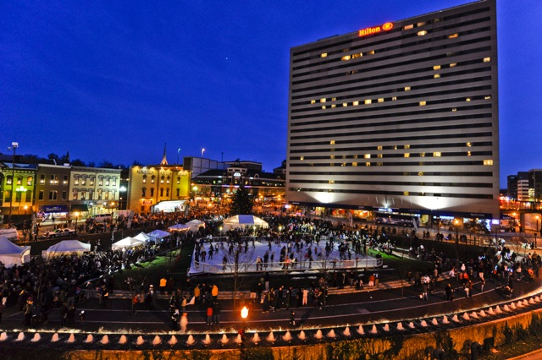

Triangle Park Site Map

Upper Fountain Terrace
The South Allée Walkway

The North Allée Walkway

Lower Lawn
Upper Lawn
Upper Tree Terrace
Lower 360 Arc Fountain Terrace

T Terrace

Triangle Park Café
The Reading Room

Fees
Estimated fees will only be given after a complete proposal is submitted and reviewed.

NOTE: A large part of Triangle Park’s revenue comes from fees charged to those who wish to use our park spaces for a commercial, profitable, promotional, or exclusive event. All site fees are used to operate, maintain, and improve the park’s beauty and functionality.

The fee for your event is determined by the following, amongst other considerations:

Type of Event: Whether the event is corporate, commercial, promotional, informational, or public.

Disruption of Public: Whether the event disrupts public use of the park, including obstructing pedestrian traffic flow or closing off any part of the park to the public.

Construction: If extensive construction (large structures) is required or large/heavy duty equipment is necessary.

Length of Time: The total amount of time in the park from load-in through load-out. Fees are determined according to the details in your proposal. The more detailed your proposal, the more quickly and accurately we can estimate your fee.

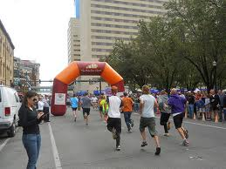
The Bourbon Chase

Every fall thousands of runners compete in this 200-mile relay race through the Blue Grass Bourbon Trail, finishing
at Triangle Park.

Over 250 teams and 3,000 runners and their supporters converge at the finish line at the park in downtown Lexington for an evening of bourbon tasting and celebration. The Upper Fountain Terrace hosts the band which entertains the visitors and participants.

Supplemental Costs & Permits

Liability Insurance
Event planners may be required to provide liability insurance for use of the park. A typical policy covers a minimum of $1 million per occurrence, naming Lexington Center Corporation as additional insured. Workers compensation must meet Kentucky statutory requirements.

Damage Deposit
All events must provide a deposit to pay for any damage to park property or other violations of the site agreement. The deposit amount is based on the size and nature of the event.

Park Amenities
If your event disrupts or has the possibility of disrupting the services of park amenities (food café and others), you must work out an agreement with each disrupted amenity outside of any contracts or permits you have with the Lexington Center Corporation or the Lexington Fayette Urban County Government. Compensation for loss of revenue by park amenities may be included in those disruption agreements.

Security
There are uniformed private security officers at Lexington Center Corporation at all times to ensure public and park safety. LCC reserves the right to require designated security at LCC normal pay rates. For the protection of the park itself, however, we may require you to hire additional officers from our private security staff at an hourly rate.

Sanitation
There is sanitation service in the park during hours of operation. If your event requires additional sanitation, your staff may provide those services to our satisfaction or you may hire our staff at an hourly rate.

Permits
You will need an LCC event permit along with other permits associated with holding events in Lexington including, but not limited to, LFUCG Department of Parks & Recreation Special Events Permits, Street Activities Parking Permits, Transportation Department Permits, Department of Buildings Permits, music copyright licenses (BMI, ASCAP, and/or others), and any other license or permit that may be necessary.

We will help you determine which additional permits are required for your event. However, you are responsible for obtaining all permits, paying all fees associated with them, and providing copies of each permit to LCC in advance of your event.

Special Events Permit
You MUST apply for a Special Events Permit with the Lexington Center Corp. Once you have submitted a proposal to LCC and the application has been reviewed and approved your will be issued your permit, please submit 60 days or more in advance. Larger event should apply 90 to 120 days in advance.

Street Closings for Events
Main Street Closing is allowed by permit only. Permits are obtained through the Mayors office. The application can be found by accessing the following link: http://lexingtonky.gov/index.aspx?page=1567 or by contacting Lori Houlihan at 859.258.3123 or by email at lhoulihan@lexingtonky.gov.

Buildings Structures
All building structures, tents, etc. must be approved by LCC. Lexpo Exposition Services is aware of the esthetic and functional issues pertaining to event structures and placements and can assist you with your proposal. Contact Lexpo by calling Melissa Conley, (859) 233-4567 ext. 3781, or visit http://www.lexingtoncenter.com/lexpo-exposition-services.

Additional Guidelines

Alcohol
Alcohol purchased in the parks café is allowed only in the park. Removal of alcohol from the park is prohibited. No alcohol beverages are allowed to be brought into the park.

Bathrooms
Triangle Park bathrooms are open to patrons of the café and special events during park hours. There are two unisex bath rooms. If you anticipate large crowds for your event, you may want to include portable toilets in your event proposal. Portable toilets are typically placed on Main Street next to the park in the empty lane.

Electricity
The Upper Fountain Terrace has 3 phase 60 amp service, The Upper Tree Terrace and The Upper Lawn has 3 phase 100 service, The Lower Lawn and the Lower 360 Arc Fountain Terrace provides 3 phase 160 and 100 amp service. The Allée Walkways have dedicated 20 amp service at each light post and 3 phase 60 amp service can be accessed from Main Street. If your event requires its own generator, it must be placed on Main Street at a location approved by LCC. Note: overloading circuits may interrupt service.

Food
The café at the park is the preferred food service provider and they can help you with any catering needs for your event. The café in the park holds the liquor license for Triangle Park and is the exclusive provider for beer and alcohol.

Tents and Event Structures
Lexpo Exposition Services is the provider for event structures used in Triangle Park. The park has standards and requirements of quality for all tents, platforms and other event structures of which Lexpo is familiar. Lexpo can assist you with your event needs. For specific information on tents, platforms and other event structures to be used in Triangle Park, please contact Melissa Conley at (859) 233-4567 ext.3781, or visithttp://www.lexingtoncenter.com/lexpo-exposition-services.

Furniture
The chairs, tables, and umbrellas in the park are for public use at all times. However, if you would like to use our furniture for your event or audience, you may request it in your proposal. You may also request to have furniture removed from the park if necessary for your event.

Gardens/grounds
The gardens, lawn, foliage, concrete and pavers must be protected from damage during load-in, load-out, and throughout your event. We will work with you to devise an appropriate protection plan.

Hours
Events must take place within posted park hours, unless otherwise approved. During the summer, the park is open from 7:00am to 12:00am. Closing times are earlier at other times of the year. A complete schedule can be found online at. www.triangleparklexington.org.

Lawn
The availability of the Lawn depends on weather conditions on the day of and days prior to the event. If you plan to have the Lawn as a part of your event, please have an alternate plan in case the Lawn is unavailable. Structures are not permitted to be placed on the Lawn.

Load-in/out
The park and surrounding sidewalks should remain open to the public at all times unless there is a danger to the public and a brief closure is absolutely unavoidable. No cars or trucks are allowed inside the park. Please provide LCC your load-in/out plan with your application. Our staff can assist you with any questions.

Parking
Downtown Lexington has ample parking. Please direct your participant toward the public parking in the Victorian Square garage on Short Street, or the surface parking on High an Short Streets. Street parking is free on weekends and after 5 pm on weekdays.

Park rules
Events must uphold the posted park rules regarding alcohol and drug use, dogs, ball playing, etc. Smoking is prohibited in Triangle Park. Members of the public who want to use the park but don't wish to participate in your event cannot be barred from the park and no event can completely close the park to the public.

Photography and filming
Groups who wish to use the park for commercial photography or videography, NOT in conjunction with a park event, must apply for a permit from LCC. There is an hourly fee based on appropriateness to the park, disruption to the public’s use of the park, crew size, complexity of set-up, amount of equipment brought into park, and space used in the park. You must also have liability insurance naming Lexington Center Corporation as additional insured. Triangle Park photo/film permit applications can be found online at www.triangleparklexington.org.

Planters
There are many horticultural planters in and around the park. You may request to have our staff remove/rearrange some or all planters if necessary for your event at an additional cost.

Signage
Any and all event signage or signage distribution in the park must be approved by LCC before the event.

Trash removal
All trash generated from an event must be bagged and removed from the park at the end of the event. Trash cannot be left next to garbage cans or on the curb. We suggest hiring a private trash carting service. All cardboard must be removed from the park after an event. Failure to properly remove trash can result in an additional fee.

Weather
Events are rain or shine. Rain dates are not typically given.
Wireless
Free wireless computing is available at all times. If you would like to include wireless features in your event, please include the details in your proposal and keep in mind there may be additional fees.

Proposal Outline

In order to determine whether your proposed event is appropriate for Triangle Park and to determine an appropriate site fee, please complete a proposal following the outline below and submit according to the instructions on page 2 of the Event Planning Guide.

- Contact Information
  - Name of event organizer/contact.
  - Address, phone & fax number, e-mail address.
  - Production company (PR firm, marketing company, etc.).
  - Address, phone & fax number, e-mail address.
  - Sponsor/client.

- Event Information
  - Event logistics.
  - Proposed date(s).
  - Alternate plan in the event of rain (rain dates are typically not given).
  - Start and end times.
  - Event Description.
  - What is the concept of the event?
  - Is the event public or private?
  - Who is the audience for your event?
  - How many attendees do you hope to attract or invite?
  - What is the purpose/goal of your event?
  - What is the promotion plan? How will your event be marketed or publicized prior to the event date? Do you have a media partner (newspaper, radio/TV station)?
  - Will there be a press conference before and/or on day of event? On or off-site?
  - Do you have a celebrity connected to your event?
  - Will he/she be in the park?
  - Is there a charity component to your event?
  - Will food or beverage be distributed at your event?
  - Is there a computer component to your event?
  - Why are you choosing Triangle Park for your event?
  - Have you considered other locations? Which ones?

- Detailed Site Plan and Production Schedule
  - Site plan for the park (use plan provided within this guide).
  - Site plan for use of Main Street or other adjacent streets/sidewalks
  - Size of production crew.
  - Number and description of vehicles to be unloaded, if necessary. Please specify location of unloading.
  - Description of all structures/machines (forklifts, scaffolding, etc.) to be used in production (dimensions, weight, height, etc.)
  - Load-in and load-out times
  - Will you have a security company on-site? Please give name and contact information.

- List of Equipment
a. What do you propose to bring into the park?
b. Please list all items such as tables, cables, extension cords, signs, speakers, mics, lighting, staging, tents, generators, stanchions, barricades, ballasts, etc.
c. Include decorative and promotional items such as balloons, flyers, giveaways, refreshments, etc.

5. Aesthetic Components
- Indicate on the park map (page 4) where all elements will be located (tents, displays, etc.)
- Provide examples of all signage to be displayed. How will signage/banners be hung, weighted, displayed?
- If necessary, draw or otherwise depict how the completed set-up will look?
- Does your event include music? What kind? Live or taped?
- Will your event have an emcee? A celebrity spokesperson or attendee?
- Will any radio stations be involved?
- Provide examples or detailed descriptions of all products, giveaways, brochures, flyers, etc. intended for distribution at the event.
- Will you have street teams?

Questions?
If you have a question that is not answered in the Event Planning Guide, please contact Jana Hatton.

Contact Information
Lexington Center Corporation
Direct Phone: (859) 233-4567 x 3292
Fax: (859) 253-2802
Email: jhatton@lexingtoncenter.com

